**Manual for transmitting Analog and Digital data through zigbee wireless modules**

The XBee/XBee-PRO RF Modules support ADC (Analog-to-digital conversion) and digital I/O line passing. In this manual we will read the data from a 10k potentiometer through DIO3 pin of the XBEE module and transmit it to another module connected in PC. We shall then read the data using x-ctu software.

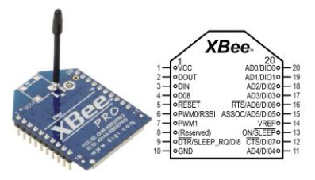**Circuit Diagram:**

**3.3v**

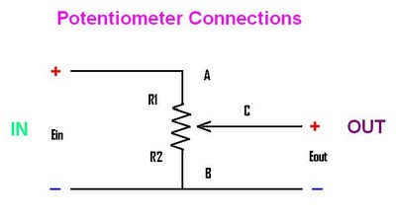

**3.3v**

**3.3v**

**Fig 6.1 Circuit Diagram**

This above circuit can be used for both ADC and Digital but in Digital you can omit VREF.

**Configuration of xbee in Digital mode:**

**Step 1 : Configuration of xbee modules in Unicast mode.**

Make two xbee modules in unicast mode details of configuring in unicast mode is given in manual for unicast mode.

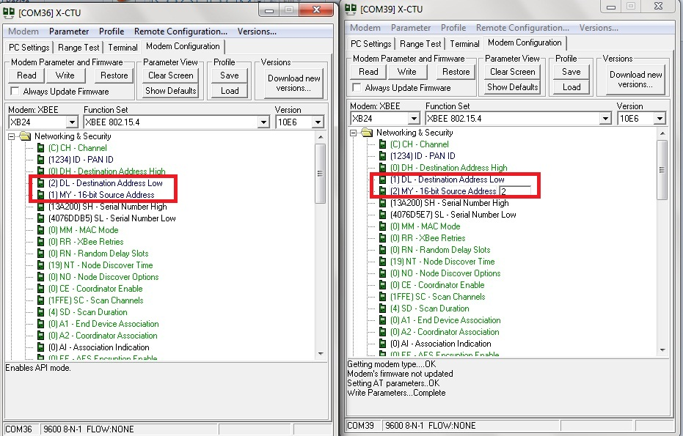

**Fig 6.2 Unicast configuration**

**Step 2: API enable.**

For the Xbee module connected to Potentiometer, under Serial Interfacing in modem configuration tab of X-CTU window enable API.

|  |  |
| --- | --- |
| Serial interfacing |  |
| AP-API Enable | 1-API ENABLED |

There is no need for this setting to be done in Xbee module connected to PC.

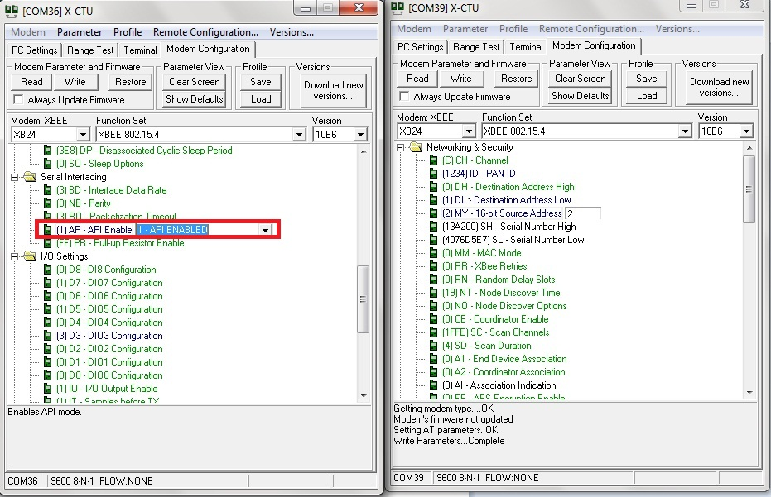

**Fig 6.3 API enable**

**Step 3:DI Configuration.**

Enable DIO3 port in I/O settings in digital mode for the Xbee connected to potentiometer the ADC as shown below

|  |  |
| --- | --- |
| I/O Settings |  |
| D3-DIO3 Configuration | 3-DI |

Do not do this setting for the Xbee connected to the PC

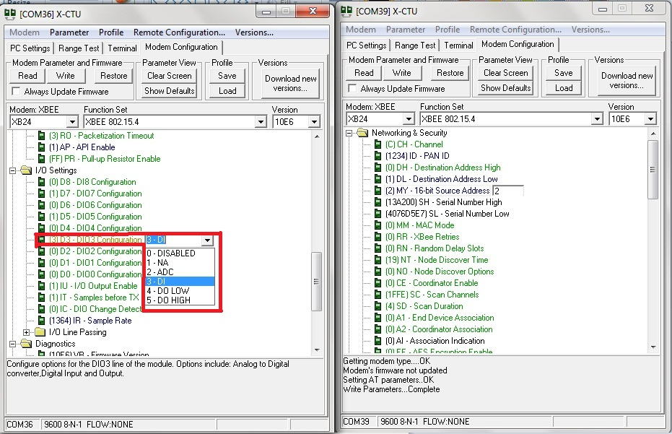

**Fig 6.4 Pin configuration**

**Step 4: Sample Rate**

Now adjust the Sample rate in I/O settings for xbee connected to potentiometer.

|  |  |
| --- | --- |
| I/O Settings |  |
| IR-Samples Rate | Anything between 0-0XFFFF X 1 MS |

Suppose you want a sample rate of 5 sec give sample rate as =(5/1ms)in hex

=0x1388

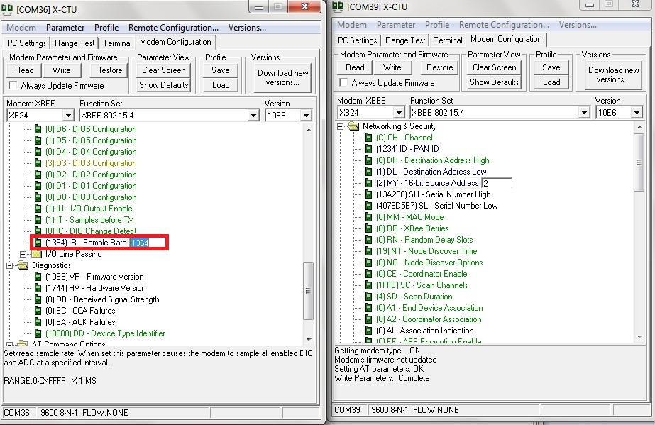

**Fig 6.5 Sample rate configuration**

Now write this configuration in your Xbee modules by clicking on write option on top of the window.

**Key Terms:**

* **API (Application Programming Interface)** Operation is an alternative to the default Transparent Operation. The frame-based API extends the level to which a host application can interact with the networking capabilities of the module.
* **AP-API enable**- <Serial Interfacing> The AP command is used to enable the RF module to operate using a frame-based API instead of using the default Transparent (UART) mode.
* DIO Pin Change Detect- When “DIO Change Detect” is enabled (using the IC command), DIO lines 0-7 are monitored. When a change is detected on a DIO line, the following will then occur
  + An RF packet is sent with the updated DIO pin levels. This packet will not contain any ADC samples.
  + Any queued samples are transmitted before the change detect data. This may result in receiving a packet with less than IT (Samples before TX) samples.
* **Sample Rate-** The Sample Rate (Interval) feature allows enabled ADC and DIO pins to be read periodically on modules that are not configured to operate in Sleep Mode. When one of the Sleep Modes is enabled and the IR (Sample Rate) parameter set, the module will stay awake until IT (Samples before TX) samples have been collected. Once a particular pin is enabled, the appropriate sample rate must be chosen. The maximum sam-ple rate that can be achieved while using one A/D line is 1 sample/ms or 1 KHz (Note that the modem will not be able to keep up with transmission when IR & IT are equal to “1”).

**Step 5: Hardware connections**

Disconnect the USB cable of the Xbee module to be connected to potentiometer from the PC and make the necessary connections according to the circuit diagram.

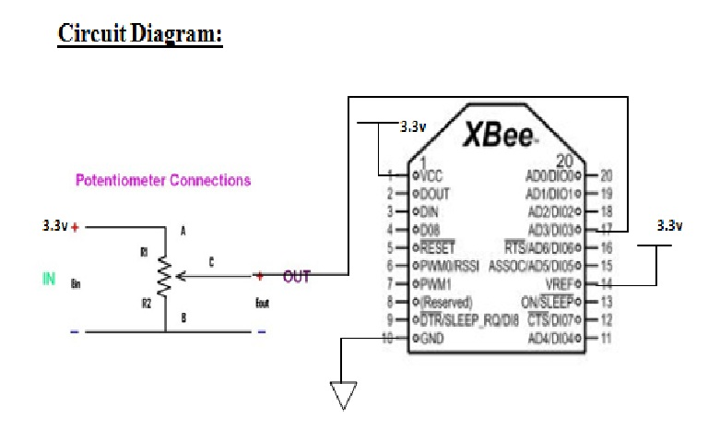

**Fig 6.6 Circuit Diagram**

Xbee needs a 3.3 V power supply.

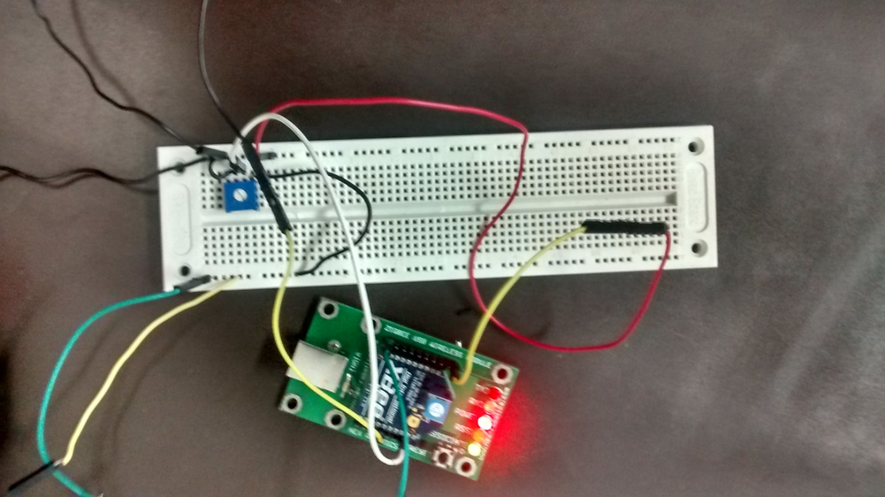

**Fig 6.7 a visual of how actual circuit looks**

**Step 6: Show Hex**

Now power on the circuit. To receive the data as packets from the Xbee connected to potentiometer to the Xbee connected to PC. We can read the data in terminal window in X-CTU software in the PC. We should read this data in HEX. Click on the show hex button on the top.

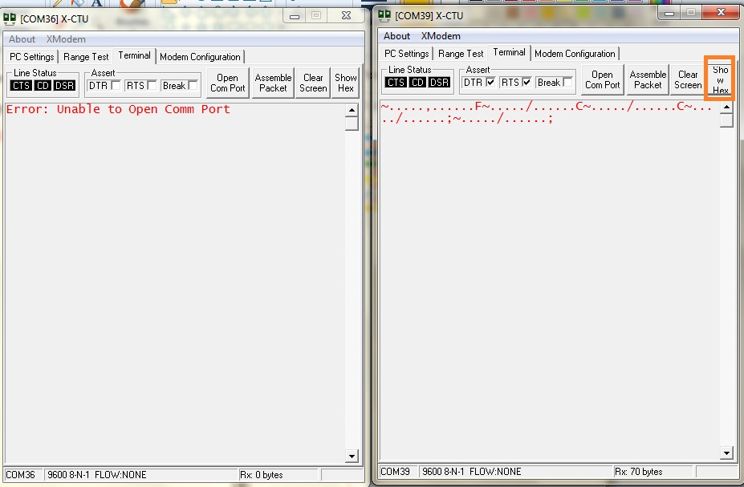

**Fig 6.8 Show hex**

**Step 7: Reading input HEX data**

After clicking on show hex you’ll be able to see 14 bytes data being received at the given sample rate . And each byte has its own representation which is clearly explained below,

7E 00 0C 83 56 78 2E 00 02 00 18 001836

Where the UART API data stream can be broken down as:

|  |  |
| --- | --- |
| 7E | Start Delimiter |
| 00 0C | Length Bytes |
| 83 | API Identifier Byte for 16bit DIO data (82 is for 64bit DIO data) |
| 56 78 | Source Address Bytes |
| 2E | RSSI Value Bytes |
| 00 | Option Byte |
| 02 | Sample Quantity Byte |
| 00 18 | 00000000 00011000 Channel Indicator * |
| 00 18 | Sample Data DIO 3 & 4 (Where 1 represents high and 0 represents low) |
| 36 | Check sum |

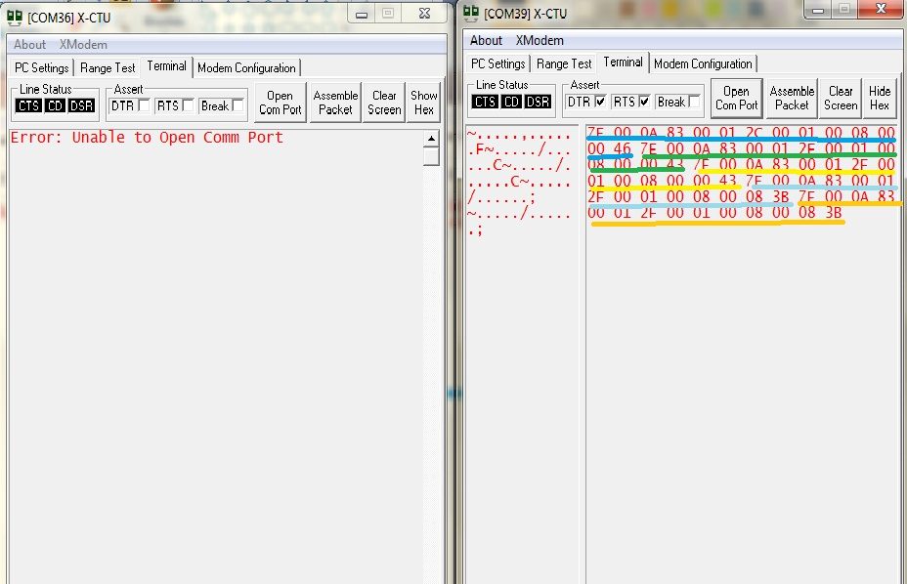

**Fig 6.9 Reading packets**

Note- Each colour represents each packet of data.

**Step 8: Assessing the data for Digital configurations**

To read digital values keep the potentiometer in max value for digital high and min value for digital low. You’ll get the output accordingly in the terminal window.

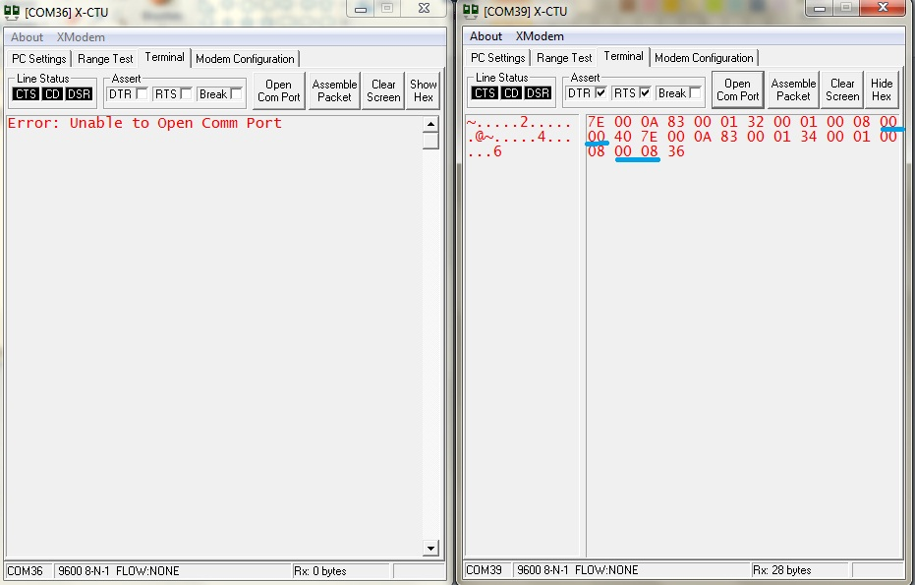

**Fig 6.10 reading digital data**

Note- 00 00 represents a digital low at DI3 pin.

00 08 represents a digital high at DI3 pin. (If DI pin is changed the output high will change correspondingly)

**Configuration of xbee in ADC mode:**

For ADC configurations follow the steps 1 to 7 of digital configuration except step 3 where you have to configure the DIO3 pin as ADC instead of DI

|  |  |
| --- | --- |
| I/O Settings |  |
| D3-DIO3 Configuration | 2-ADC |

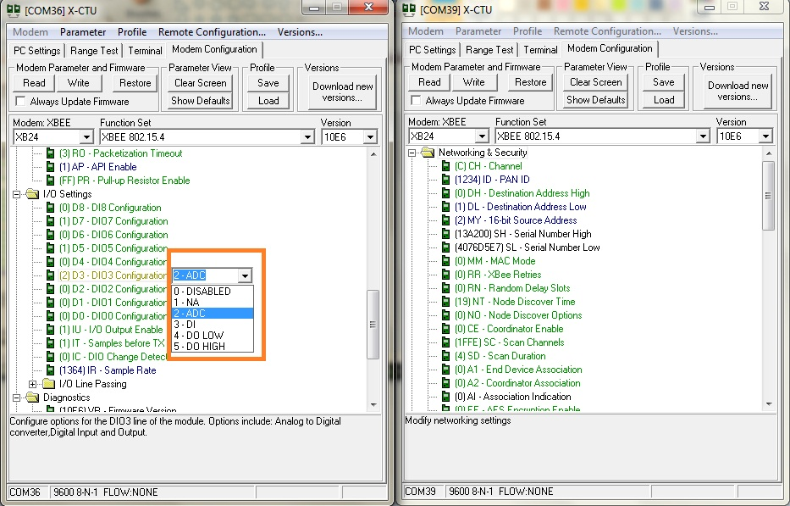

**Fig 6.11 pin configuration for ADC**

After completing the above procedure now open the terminal window and adjust the potentiometer you’ll receive the output accordingly.

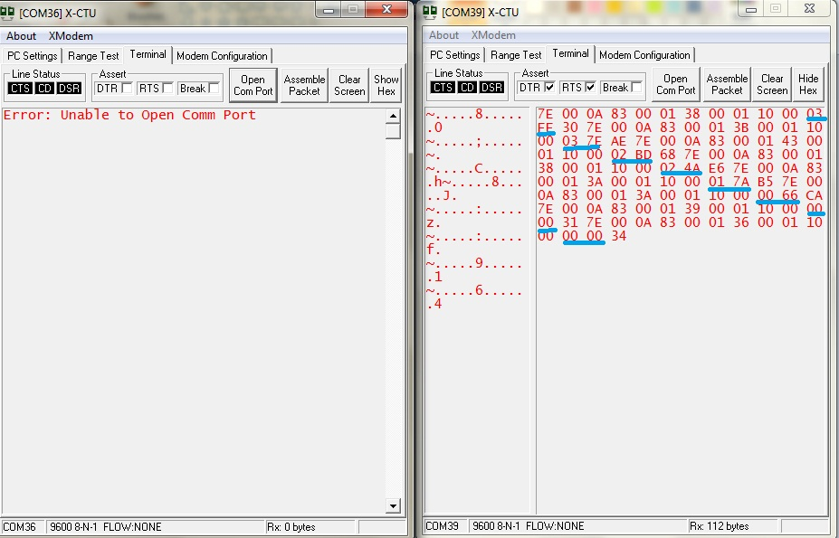

**Fig 6.12 Reading transmitted ADC data**

In the above figure 03 FF=1024 ( potentiometer is in maximum position)

03 7E=894

02 BD=701

02 4A=586

01 7A=378

00 66=102

00 00= 000( potentiometer is in minimum position)

This is a sample of data for moving potentiometer from maximum to minimum position.

This may vary in your case. Since ADC is configured in 10 bit mode the values vary between 0 to 1024.